Lab No. 09

Static Data Member and Methods

Lab Objectives | Following are the lab objectives:  - Learn to define static data members in classes  - Learn to define static member methods in classes
Student ID | 10011 | Student Name |  | Sajjal Tariq
 | Marks |  | Obtained Marks |  | Comments
Task 1 | 20
Task 2 | 20
Task 3 | 20
Total Marks | 60
 | Lab Instructor

Lab Objectives and CLOs Mapping

Lab Objectives | CLOs
Lab Objectives | a | b | c
1
2
3

Instructions
- This is individual Lab work/task.
- Complete this lab work within lab timing.
- Discussion with peers is not allowed.
- You can consult any book, notes & Internet.
- Copy paste from Internet will give you negative marks.
- Lab work is divided into small tasks, complete all tasks sequentially.
- Show solution of each lab task to your Lab Instructor.
- In-Lab Exercises/Tasks
- Write your code at provided space after each question
- You need to upload code for all tasks at Google Class.

C++ Static Data Members
Static data members are class members that are declared using static keywords. A static member has certain special characteristics which are as follows:
- Only one copy of that member is created for the entire class and is shared by all the objects of that class, no matter how many objects are created.
- It is initialized before any object of this class is created, even before the main starts outside the class itself.
- It is visible can be controlled with the class access specifiers.
- Its lifetime is the entire program.

Syntax

Static data members are useful for maintaining data shared among all instances of a class. The C++ Course explains how to implement static data members, ensuring you understand their significance in C++ programming.
Example
Below is the C++ program to demonstrate the working of static data members:
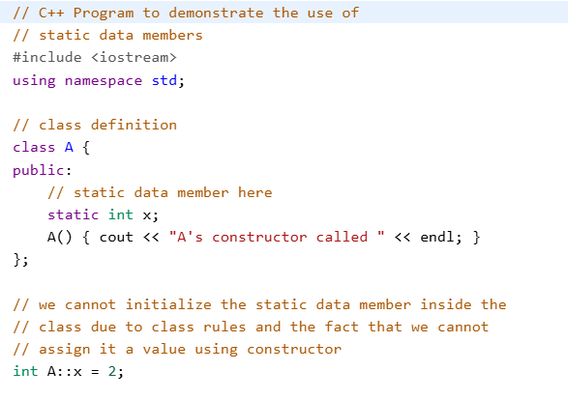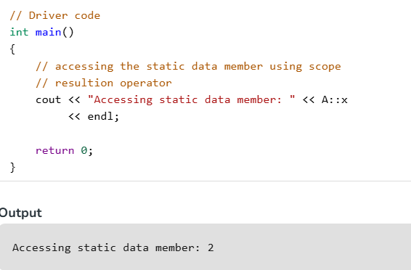

Defining Static Data Member
As told earlier, the static members are only declared in the class declaration. If we try to access the static data member without an explicit definition, the compiler will give an error.
To access the static data member of any class we have to define it first and static data members are defined outside the class definition. The only exception to this are static const data members of integral type which can be initialized in the class declaration.

Syntax
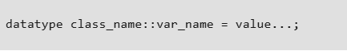
For example, in the above program, we have initialized the static data member using the following statement:
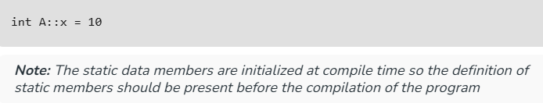

Inline Definition of Static Data Member since C++ 17
The C++ 17 introduced the inline definition of the static data members of type integral or enumeration which was not allowed in the previous standards. This simplifies the definition of the static data members.
Syntax
// inside class definition
...
static inline data_type var_name = value/expression;
....

Accessing a Static Member
We can access the static data member without creating the instance of the class. Just remember that we need to initialize it beforehand. There are 2 ways of accessing static data members:

1. Accessing static data member using Class Name and Scope Resolution Operator
The class name and the scope resolution operator can be used to access the static data member even when there are no instances/objects of the class present in the scope.
Syntax
Class_Name :: var_name
Example
A::x

2. Accessing static data member through Objects
We can also access the static data member using the objects of the class using dot operator.
Syntax
object_name.var_name
Example
obj.x

Example to Verify the Properties of the Static Data Members
The below example verifies the properties of the static data member that are told above:
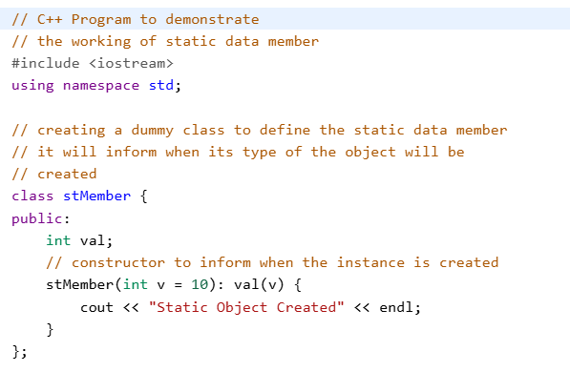
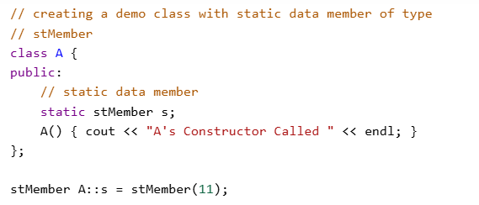
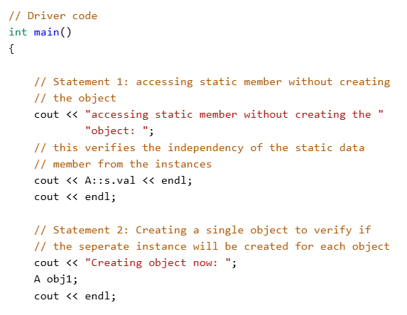
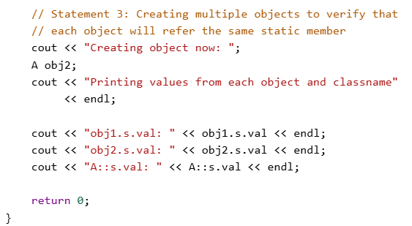
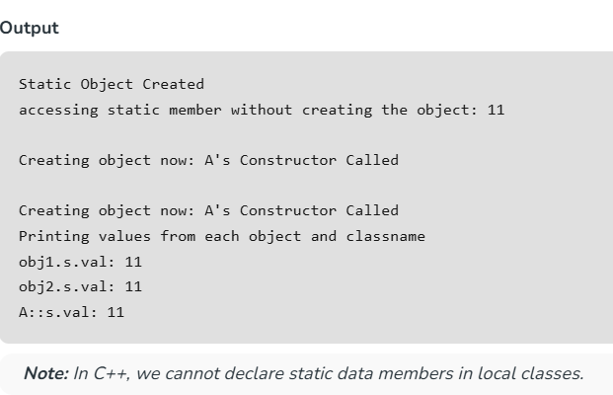

Lab Tasks
Task 1 (15 mark)
Create a SavingsAccount class. Use a static data member annualInterestRate to store the annual interest rate for each of the savers. Each member of the class contains a private data member savingsBalance indicating the amount the saver currently has on deposit. Provide member function calculateMonthlyInterest that calculates the monthly interest by multiplying the balance by annualInterestRate divided by 12; this interest should be added to savingsBalance.
Provide a static member function modifyInterestRate that sets the static annualInterestRate to a new value.
Write a main function to test SavingsAccount class. Instantiate two different objects of class SavingsAccount, saver1 and saver2, with balances of $2000 and $3000, respectively. Set the annualInterestRate to 3 percent. Then calculate the monthly interest and print the new balances for each of the savers.
Then set the annualInterestRate to 4 percent, calculate the next month's interest and print the new balances for each of the savers.
Code: 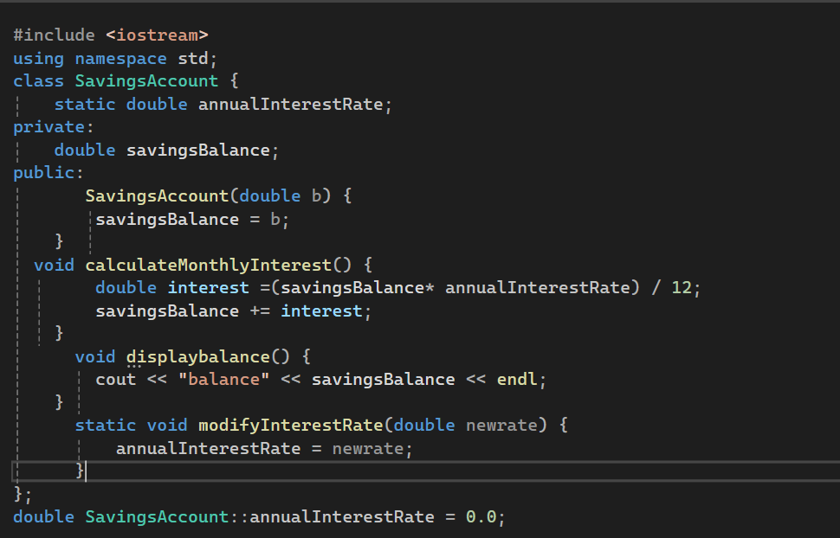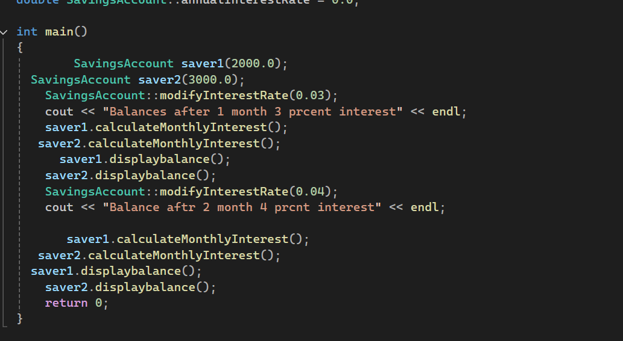
Output: 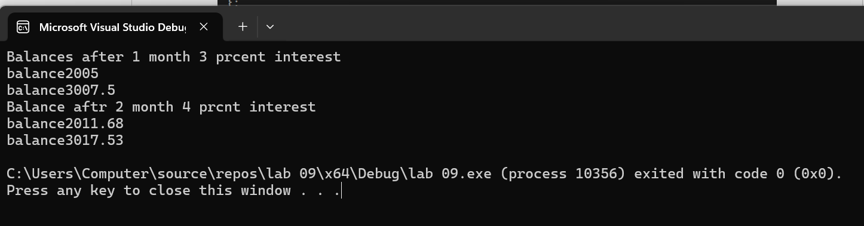

Task 2 (15 mark)
Write program to count the number of objects created and destroyed for a class using static data members and static member functions. You can develop any class of your choice.
Code:
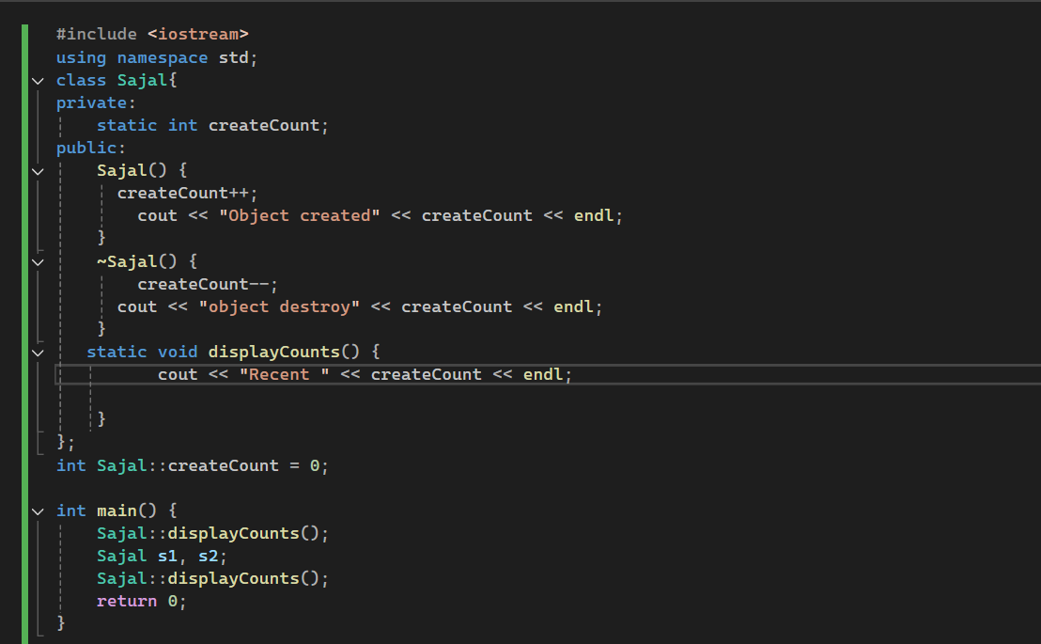
Output:
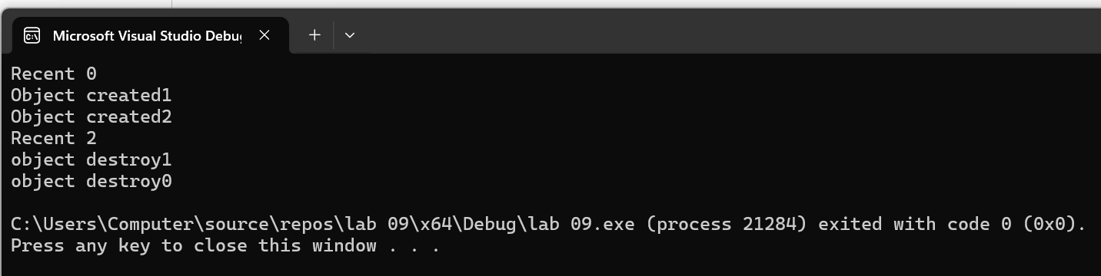

Task 3 (15 mark)
Create a Calculator class that has following methods:
- sum,
- multiply
- divide
- modulus
- sin
- cos
- tan
The user should be able to call these methods without creating an object of Calculator class. Demonstrate working of your class.

Code:
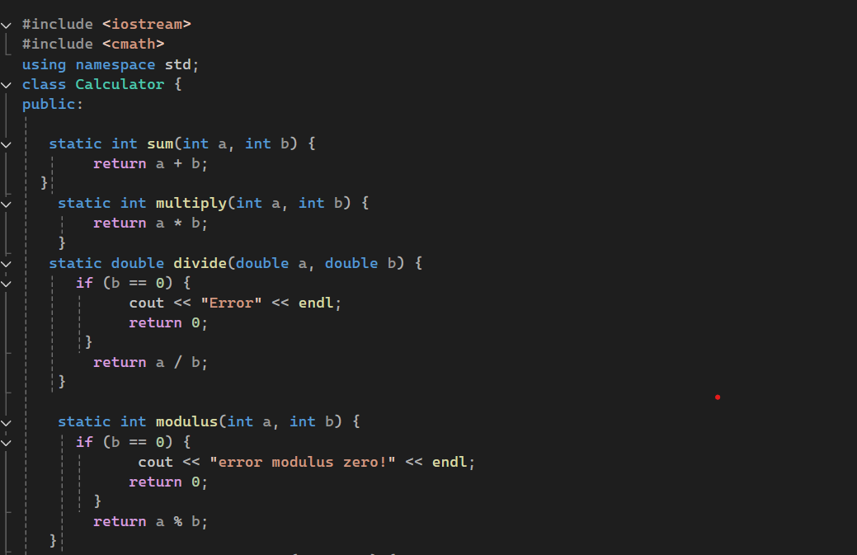
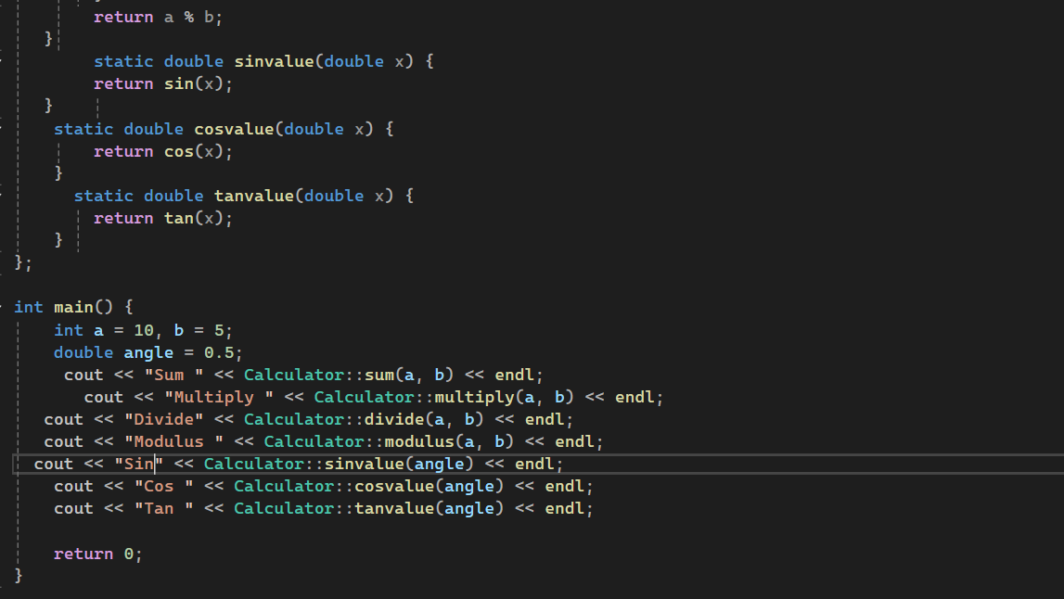

Output:
